|  |  |
| --- | --- |
| **STUDENT NAME** | **Abdullah Muhammad Ibrahim** |
| **STUDENT ID** | **SP20-BSCS-0027** |
| **SECTION** | **AM** |
| **ASSIGNMENT NO.** | **02** |

**OUTPUT:**

**CURRENT ACCOUNT:**

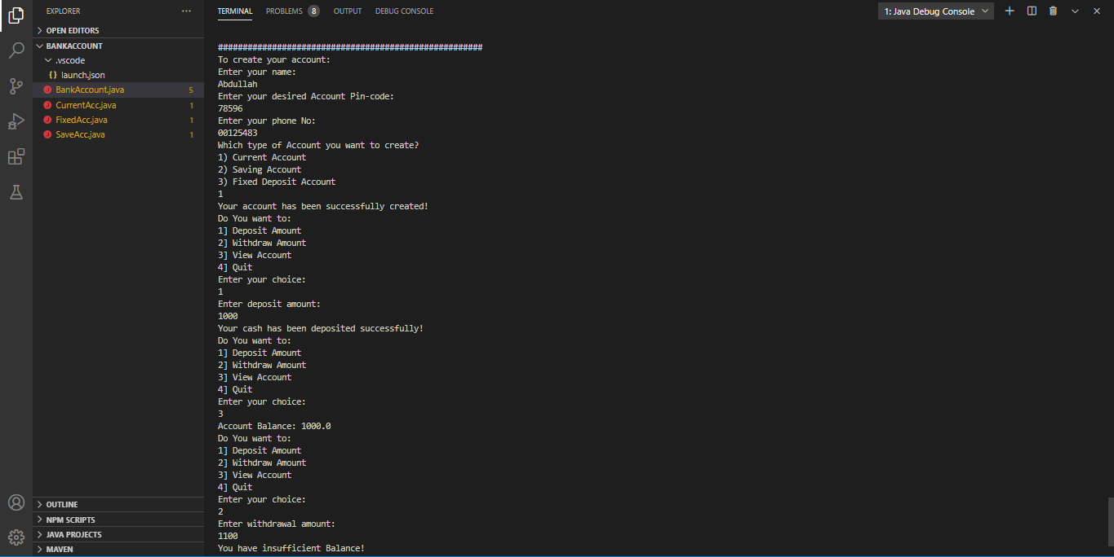

**SAVING ACCOUNT:**

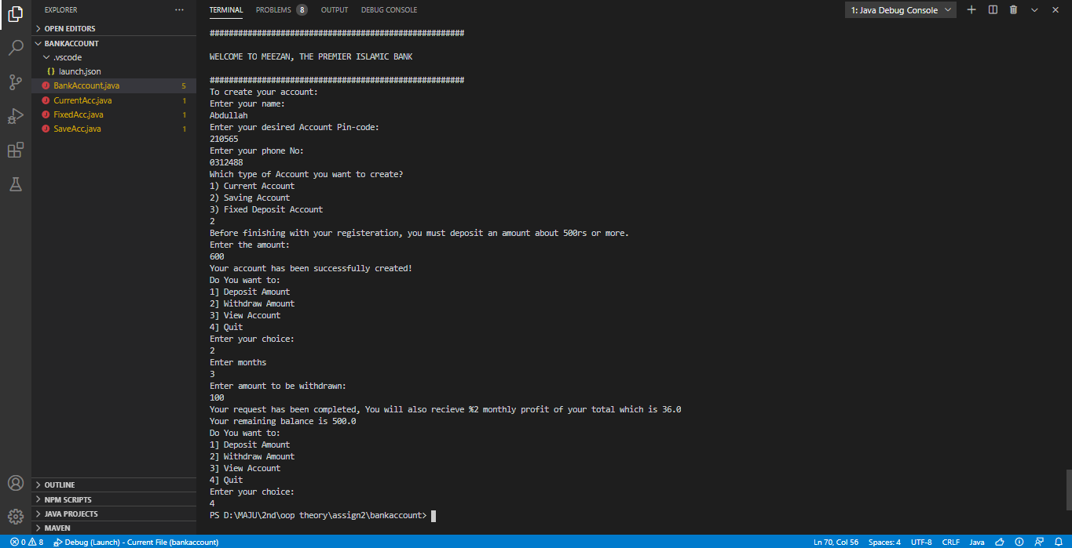

**FIXED DEPOSIT ACCOUNT:**